**Plot1.R**

#set working directory

setwd("C:/Users/Salimah/Documents/data/exdata/")

#load library data.table

library(data.table)

DT<-fread("./household_power_consumption.txt", na.strings="?")

#set date as d:m:y

DT$strDate <- as.Date(DT$Date,"%d/%m/%Y")

#select data

DT.filter<-DT[DT$strDate=="2007-02-01" | DT$strDate=="2007-02-02",]

DT.filter$Global_active_power<-as.numeric(DT.filter$Global_active_power)

rm(DT)

#output histogram to PNG

png(filename="plot1.png", width=480, height=480)

hist(DT.filter$Global_active_power,

col="red",

xlab="Global Active Power (kilowatts)",

main="Global Active Power")

dev.off()

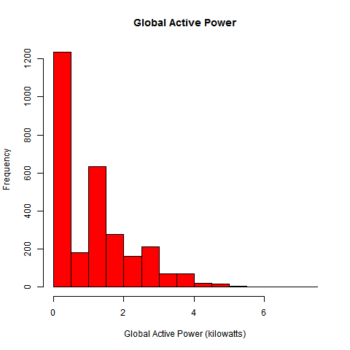

**Plot2.R**

#set working directory

setwd("C:/Users/Salimah/Documents/data/exdata/")

library(data.table)

## Getting full dataset

DT<-fread("./household_power_consumption.txt", na.strings="?")

DT$Date <- as.Date(DT$Date, format="%d/%m/%Y")

## Subsetting the data

DT.filter <- subset(DT, subset=(Date >= "2007-02-01" & Date <= "2007-02-02"))

rm(DT)

## Converting dates

datetime <- paste(as.Date(DT.filter$Date), DT.filter$Time)

DT.filter$Datetime <- as.POSIXct(datetime)

#output histogram to PNG

plot(DT.filter$Global_active_power~DT.filter$Datetime, type="l",

ylab="Global Active Power (kilowatts)", xlab="")

dev.copy(png, file="plot2.png", height=480, width=480)

dev.off()

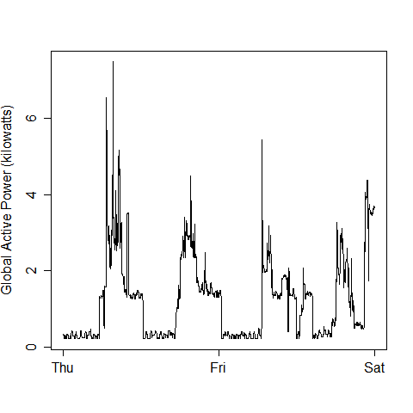

**Plot3.R**

#set working directory

setwd("C:/Users/Salimah/Documents/data/exdata/")

library(data.table)

## Getting full dataset

DT<-fread("./household_power_consumption.txt", na.strings="?")

DT$Date <- as.Date(DT$Date, format="%d/%m/%Y")

## Subsetting the data

DT.filter <- subset(DT, subset=(Date >= "2007-02-01" & Date <= "2007-02-02"))

rm(DT)

## Converting dates

datetime <- paste(as.Date(DT.filter$Date), DT.filter$Time)

DT.filter$Datetime <- as.POSIXct(datetime)

#plot the graph with legends

with(DT.filter, {

plot(Sub_metering_1~Datetime, type="l",

ylab="Energy sub metering", xlab="")

lines(Sub_metering_2~Datetime,col='Red')

lines(Sub_metering_3~Datetime,col='Blue')

})

legend("topright", col=c("black", "red", "blue"), lty=1, lwd=2,

legend=c("Sub_metering_1", "Sub_metering_2", "Sub_metering_3"), cex = 0.75)

## output histogram to PNG

dev.copy(png, file="plot3.png", height=480, width=480)

dev.off()

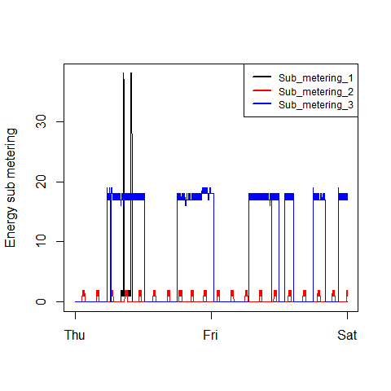

**Plot4.R**

#set working directory

setwd("C:/Users/Salimah/Documents/data/exdata/")

library(data.table)

## Getting full dataset

DT<-fread("./household_power_consumption.txt", na.strings="?")

DT$Date <- as.Date(DT$Date, format="%d/%m/%Y")

## Subsetting the data

DT.filter <- subset(DT, subset=(Date >= "2007-02-01" & Date <= "2007-02-02"))

rm(DT)

## Converting dates

datetime <- paste(as.Date(DT.filter$Date), DT.filter$Time)

DT.filter$Datetime <- as.POSIXct(datetime)

#plot the graph with legends

par(mfrow=c(2,2), mar=c(4,4,2,1), oma=c(0,0,2,0))

with(DT.filter, {

plot(Global_active_power~Datetime, type="l",

ylab="Global Active Power", xlab="")

plot(Voltage~Datetime, type="l",

ylab="Voltage (volt)", xlab="datetime")

plot(Sub_metering_1~Datetime, type="l",

ylab="Energy sub metering", xlab="")

lines(Sub_metering_2~Datetime,col='Red')

lines(Sub_metering_3~Datetime,col='Blue')

legend("topright", col=c("black", "red", "blue"), lty=1, lwd=2, bty="n", legend=c("Sub_metering_1", "Sub_metering_2", "Sub_metering_3"), cex = 0.75)

plot(Global_reactive_power~Datetime, type="l",

ylab="Global_Rective_Power",xlab="datetime")

})

## Saving to file

dev.copy(png, file="plot4.png", height=480, width=480)

dev.off()

